Top Practices
Goal Setting System

First: Get Organized and Write it all Down

Most of us have too much to do. Our "to do" list both professional and personal is overwhelming. The truth is we simply don't do very much on that list – ever. We are just keeping our nose above water so that we don't drown. We never get to the important but not urgent (no obvious fires burning) items on our list that actually matter. We are stressed out, racked with guilt, and drowning in a sea of obligations and work. Each item on your "to do" list occasionally pops into your conscious mind and screams "you have to complete me!" and then recedes back into the tar pit of things not yet done, threatening to pull you under. And then another thing pops up, yells at you, stresses you worse, and then recedes. It's no way to live, and yet it is the way most of us are living. Our fabulous devices have only made this much, much worse. And many of the books that address our stressful modern lives are focusing on teaching us how to manage our technology and to stop have it manage us.

Step One in our system is to first write it all down

- Make a 3 hour appointment with yourself that you won't break and write down absolutely everything you have on your giant "to do" list. EVERYTHING. This includes things like clean out the garage or basement. Date my spouse. Spend more time with my children, plan our vacation, fix my EHR, fire an employee, get your marketing working really well, and on and on. Write it ALL down. Think of everything and anything you are not getting done.
- Rank every item on that list as either a 1, 2, or 3. 1 means this is really important and if I could get this done in the next 12 Weeks it would have enormous gain for me. 2 means this is on the list but it's just not as important as the 1's are. And 3 means it's on the list but not at the top.
- Take all the 2's and 3's and remove them from the list. Keep them on a "to do" list, but separate them from the 1's.
- Now, if you are like most people, you will still have too many 1's. So do this again with the remaining 1's. Which items on your list are TRULY 1's of 1's? 2's and 3's? Be Ruthless. You need to get your 1's list to no more than 15 items.
- Take these 2's and 3's and put them on top of the other 2's and 3's. Save this list because you will want to have a place where all of your "to do's" are saved—not just floating around in your head interfering with your sleep at night.
- Look at the 1's that are left. These should be the most important items on your lengthy list. You have just done what Gary Keller, the author of The One Thing calls taking your "could do" list and creating your "should do" list. With a shorter list of things you really should be doing you can now begin to focus and prioritize.
- Rank this list 1,2,3,4,5,6,7,…..and so on. In true order of importance.
- After you have this ranked, let it sit for 24 hours. Look at it again and agree that it is the correct order. If yes, then pick number one, number two, and number three and get them done.
- Focus like a laser beam on these projects for the next 12 Weeks. Get help. Invest in tools or companies or employees. Get a top trusted employee (at least) working on it with you. RESOLVE to accomplish this task and to ensure that a system is in place to keep it fixed.
- In 12 Weeks when these are done—look at your list and pick the next two most important tasks and get them done as well.
- If you do this, 12 months from now you will have the top 8-12 accomplished and you will have transformed your life. You will get 90% of the gain you were looking for from the top 10 "should do's" You won't really care about the other 140 items on your list -and the truth is you weren't going to do them anyway. Keep attacking your list and do it all over again.
- I call this my Deceptively Simple Yet Extremely Powerful Tool for getting Organized. Try it— it truly works. Write your top three goals for the next 12 Weeks on the next page.
Name:

Today's Date: 12 Weeks Date:

My Top THREE GOALS for the next 12 Weeks

Be as specific as possible. How will you measure this to know you've accomplished it? When is it to be completed? I've learned from Dave Frees to add these two phrases to every goal you create: or more….or sooner. If you write a goal for instance to build your revenues to 2M in 2014. You should write –to generate 2M in revenue by December 31, 2014 or sooner. It creates a different way for you and your subconscious mind to see your goals—bigger and quicker.

Find your One Thing(s)

Gary Keller's book "The One Thing" teaches that you must find and focus on your one thing. Napoleon Hill says you should focus on your "Definiteness of Purpose" or your top top goal.

Many people struggle because they don't know what theirs is. A business goal being your ONE THING seems crass and for most of us it's not the most important thing to us. Most often our most important goals are spiritual or family related. But focusing on those as your one thing seems to not be congruent with building your practice.

Andrew Carnegie taught me the answer to this question. His definiteness of purpose was to build the greatest steel company in the world. US Steel. He did this. This was his One Thing. And only by doing this was he able to become one of the great philanthropists of all time: establishing libraries all over the US, universities and much, much more.

Your One Thing should be to build the best practice in your region—like the entire southwest—not just your city. You should be singularly focused on building your practice so that it can support and fund everything else in your life that you hold dear.

Be as specific as possible. How will you measure this to know you've accomplished it? When is it to be completed?

My own ONE THING is to build Top Practices into the absolute best company I can conceive it to be (and more).

It is true that you must have your ONE THING and there can be only one, but you can use the focusing Question from The One Thing in the other areas of your life -your relationships, your finances, your health, your Business.
My ONE THING IS:

The Focusing Question

What is the One Thing I can do such that by doing it everything else is easier or unnecessary?

The Top Practices Goal Worksheets are divided into these categories: Personal, Business, Financial, Health and Fun. Using the focusing question how can you accomplish your goals in these areas?

The Top Practices Goal Worksheets are also set up so that you can work backwards from your Lifetime Goal to the current 12 Week period that you are in. You must be able to draw a straight line from your 12 Week Goal to your Three year Vision to you Lifetime Goal.

You've got to do these goals in all the important areas of your life, because you must discover your purpose. What is it that you truly and deeply care about that gives your life purpose and meaning? Your ONE THING—building your practice to it's best possible outcome is not your purpose. It will not sustain you in the difficult moments. It must be something deeply personal that you care about. It's what gives your life meaning and purpose. THIS exercise is how you find your "WHAT?" What am I doing all of this for. If you don't have this, then keeping focused on YOUR ONE THING will be very very difficult. The following goal worksheets are designed to help you discover your purpose. Take this very seriously or risk failing.

WRITING GOALS

Mindset Number ONE: The true purpose of your practice or business is to serve YOU and to fund your IDEAL LIFESTYLE – not the other way around. YOU MUST BEGIN BY PUTTING YOUR PERSONAL LIFE FIRST AND GETTING YOUR PRACTICE PRIORITIZED CORRECTLY.

Mindset Number TWO: A goal not reduced to writing and reviewed often is a MERE WISH.

The goals you ultimately create must be S.M.A.R.T.

Specific – A specific goal has a much greater chance of being accomplished than a general goal. To set a specific goal you must answer the six "W" questions:
- Who: Who is involved?
- What: What do I want to accomplish?
- Where: Identify a location.
- When: Establish a time frame.
- Which: Identify requirements and constraints.
- Why: Specific reasons, purpose or benefits of accomplishing the goal.
EXAMPLE: A general goal would be, "Get in shape." But a specific goal would say, "Join a health club and workout 3 days a week."

Measurable – Establish concrete criteria for measuring progress toward the attainment of each goal you set. When you measure your progress, you stay on track, reach your target dates, and experience the exhilaration of achievement that spurs you on to continued effort required to reach your goal.
To determine if your goal is measurable, ask questions such as......How much? How many? How will I know when it is accomplished?

Attainable – When you identify goals that are most important to you, you begin to figure out ways you can make them come true. You develop the attitudes, abilities, skills, and financial capacity to reach them. You begin seeing previously overlooked opportunities to bring yourself closer to the achievement of your goals.
You can attain most any goal you set when you plan your steps wisely and establish a time frame that allows you to carry out those steps. Goals that may have seemed far away and out of reach eventually move closer and become attainable, not because your goals shrink, but because you grow and expand to match them. When you list your goals you build your self-image. You see yourself as worthy of these goals, and develop the traits and personality that allow you to possess them.

Realistic – To be realistic a goal must represent an objective toward which you are both willing and able to work. A goal can be both high and realistic; you are the only one who can decide just how high your goal should be. But be sure that every goal represents substantial progress. A high goal is frequently easier to reach than a low one because a low goal exerts low motivational force. Some of the hardest jobs you ever accomplished actually seem easy simply because they were a labor of love.
Your goal is probably realistic if you truly believe that it can be accomplished. Additional ways to know if your goal is realistic is to determine if you have accomplished anything similar in the past or ask yourself what conditions would have to exist to accomplish this goal.

Time Bound – A goal should be grounded within a time frame. With no time frame tied to it there's no sense of urgency. If you want to lose 10 lbs, when do you want to lose it by? "Someday" won't work. But if you anchor it within a timeframe, "by May 1st", then you've set your unconscious mind into motion to begin working on the goal.

Writing your GOALS

What are your goals?
Lifetime Three-Year Vision Next 12 Weeks
Personal/Business/Financial/Health/Fun

It’s time to write out your goals for your Personal Life, Business and Career, Your Financial Goals, Your Health Goals, and Your Fun Goals. In each section, write our your Lifetime Goals, Your Three Year Vision, and Your Plan for the Next 12 Weeks.

Your Lifetime Goals

Start with your Lifetime Goal. Gary Keller calls this your someday goal, in the 12 Week Year Brian Moran calls it your aspirational Vision. It’s essential that you take the time to think through what you truly desire with a “burning desire.” Sometimes those goals can be elusive at first. Do not let this deter you. Sometimes the goals you write in this section are your “best shot” at stating what you want. That is fine. These goals are to be written “in pencil.” Which means that we can change or adjust them as they either become clearer or are achieved and need to be revised to something much higher. No matter what, persevere and as you put your dreaming hat on you will find what you desire begins to come into focus. Sometimes your goals are already crystal clear. Always ask yourself if they are big enough, daring enough, fulfilling enough. It is important to have goals that inspire you so much that you can use them to get you through the challenges and roadblocks you will inevitably face.

This form has room for 5 Lifetime goals. If you have more then add them. If you have less than only write those. Three to Seven great Lifetime goals is most common. Even though these are lifetime goals you must put time frames on them. If you don’t know the correct time frame take your best guess, but time bound goals are essential.

Your Three-Year Vision

Next you need to write your vision of where you need to be in three years from today in order to be on your path to achieving your lifetime goals. All of your 3 year goals must be connected to a lifetime goal. If they aren’t you need to review your lifetime goals. Did you miss one? If not, then the goal you’ve just written may not be a goal. You can’t work on three year goals that don’t support ultimate goals. These become much more specific and focused and should reflect that in their writing.

Your 12 Week Goals

This is the part of goal work that involves serious, focused and intense execution. Read “The 12 Week Year” by Brian Moran for an excellent discussion of executing in 12 week periods. In this section you make serious plans for achieving important milestones for your goals in the next 12 weeks.

This is a working document. You can use it in two ways. To focus you in the five areas of your life and to get things done much more quickly and effectively. So you should have 12 week goals in each area of your life. If you want to lose weight, you need goals and a plan. If you want to be achieving your financial goals you need goals and a plan for saving and investing. If you want to improve your marriage or your relationship with a child you need goals and a plan to achieve it. If you want your practice to grow and prosper you need a marketing and management plan.

Therefore you DO NEED to get super specific and think this through now, BUT in truth you can’t do everything at once. At the outset of this program we discussed the Top Three Goals you must be focusing on in the next 12 weeks. When you complete these goals –and it will take some real action to do this –you need to check the Top Three Goals you’ve already described and make some decisions. Are these the right top three goals? If not –then change them based on the real work you’ve just completed. Then for the next 12 weeks hyper focus on these goals and make some real progress. At the end of that 12 week period, take one week off and then attack your next three goals in the next 12 week period. By doing this you will begin to accomplish more than you ever have in the past.

It is important now to point out that if you want to lose weight, you can’t wait until that goal finally comes up to the top three. You’ve got to be working that plan every single day, however you could take the summer for instance and raise your health goal to the very top of the list and achieve more in 12 weeks than you ever have before and in the fall attack your marketing with renewed vigor and health. Get the picture? This is something you must commit to and review every day if you want to finally live that successful life that you and all of us so desire.

A note about Personal Goals. This is the one area people struggle with the most –what is this? It can include your spiritual goals, your relationships, your homes, college for your children etc. These are goals that do not fall into the other main areas.

A note about Fun Goals. This is the one area everyone wants to skip because they think it isn’t important. Nothing could be further from the truth! Without your fun goals –vacations, classes for piloting an airplane, painting, putting –it doesn’t matter what –without these goals life is pretty mundane and routine. At the end of your life you will not remember many of these goals that are so important today, but you will remember and cherish all of the fun goals.

My Personal Goals Are:

Lifetime Goals and Visions

1.

2.

3.

4.

5.

Three-Year Vision for each goal

1.

2.

3.

4.

5.

My 12 Week Plan for my personal Goals. (You might be focusing on only one in this 12 week period or none depending on your focus.)

1.

2.

3.

4.

5.

My Business Goals Are:

Lifetime Goals and Visions

1.

2.

3.

4.

5.

Three-Year Vision for each goal

1.

2.

3.

4.

5.

My 12 Week Plan for my personal Goals. (You might be focusing on only one in this 12 week period or none depending on your focus.)

1.

2.

3.

4.

5.

My Financial Goals Are:

Lifetime Goals and Visions

1.

2.

3.

4.

5.

Three-Year Vision for each goal

1.

2.

3.

4.

5.

My 12 Week Plan for my personal Goals. (You might be focusing on only one in this 12 week period or none depending on your focus.)

1.

2.

3.

4.

5.

My Health Goals Are:

Lifetime Goals and Visions

1.

2.

3.

4.

5.

Three-Year Vision for each goal

1.

2.

3.

4.

5.

My 12 Week Plan for my personal Goals. (You might be focusing on only one in this 12 week period or none depending on your focus.)

1.

2.

3.

4.

5.

My Fun Goals Are:

Lifetime Goals and Visions

1.

2.

3.

4.

5.

Three-Year Vision for each goal

1.

2.

3.

4.

5.

My 12 Week Plan for my personal Goals. (You might be focusing on only one in this 12 week period or none depending on your focus.)

1.

2.

3.

4.

5.

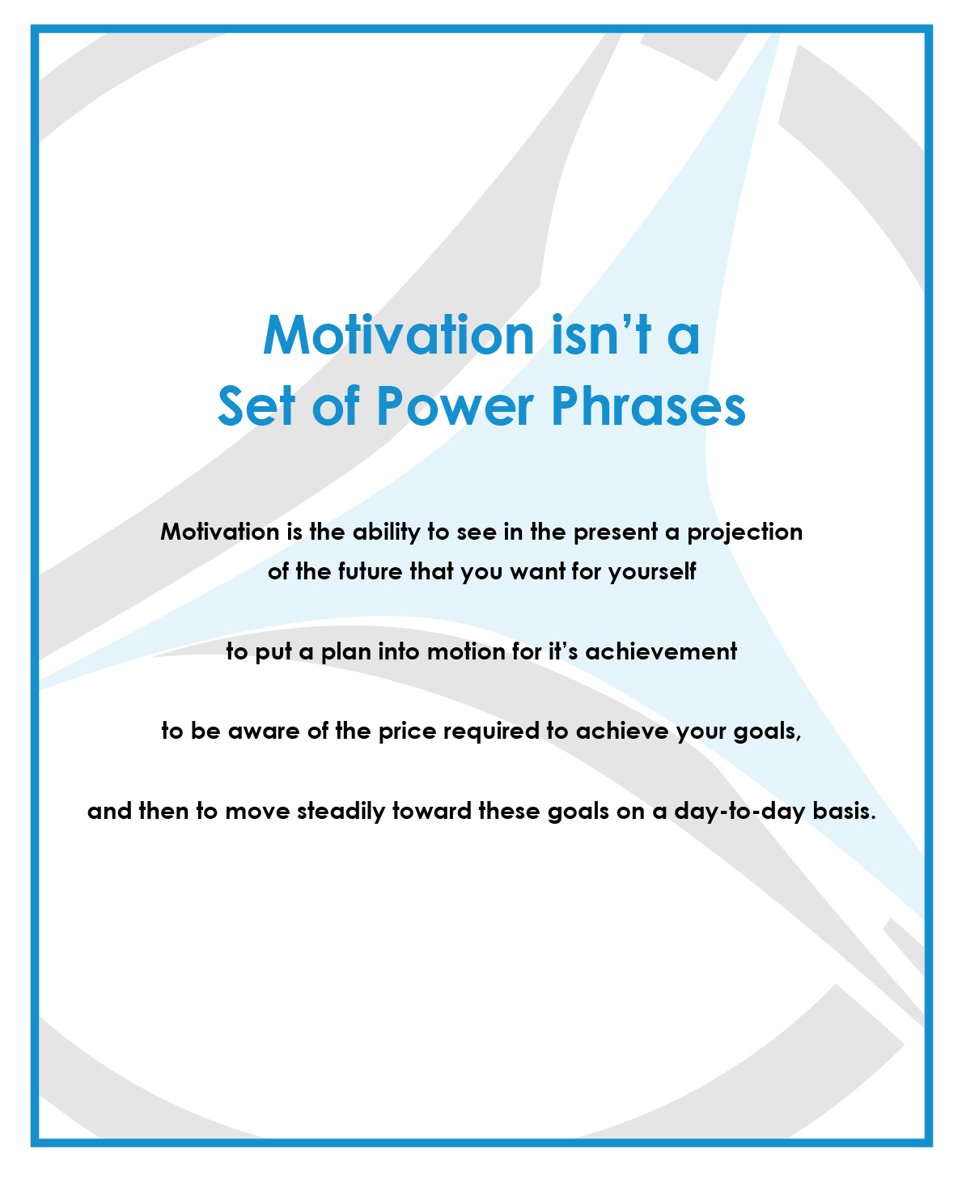
The Slight Edge Strategy to get it done

Goals are useless if you don't have a Slight Edge Strategy for the attainment of each goal. This is where you discover just how serious you are about attaining them. Every goal that you are focusing on can be attained by using the slight edge strategy of doing the seemingly small and insignificant things you need to do every day and never stopping.

Think of how slight edge snow is.

As I began to write this, snow was falling and I looked out my window and watched the first snowflakes lightly settle onto the tree just outside my second story window. Each snowflake was so small and fragile. The first flakes seemed to dissolve and nothing was happening. I looked out 20 minutes later and these small flakes ONE AT A TIME had covered the trees in a light layer of white.

Beautiful.

Four hours later the whole state was in a state of paralysis. Giant trucks were blocking my driveway. Digging out of the heavy wet snow was back breaking. Neighbors were everywhere, snow blowers were throwing it high in their neighbor's yard and here comes that plow blocking the driveway that had just been cleared. More milk and bread were sold in the hours before this deluge than in the whole week before, weirdly. All happening—one little fragile flake at a time.

Snow is so Slight Edge.

You need a Slight Edge strategy to get your goals accomplished. If you stay at it, small and fragile though those tasks may be you will achieve it just as the snow shut down the entire Northeast US.

The Slight Edge tool to use is your Action Plan for that goal. Everyone of your Top Three Goals needs an Action plan and that action plan must be used every single day that you are working. (and if you are doing this right—NOT used on the days you're not working). This action plan has steps (ACTION ITEMS) or tasks.

These action items have Sub Action Items—the smaller things that have to happen in order for the action item to be completed on time or sooner. Every task has a date for completion and a person who is responsible for it. These must be reviewed daily or weekly and the progress on every item reported to the team. The person responsible for the Action Plan updates it immediately after the meeting and emails it to the team immediately. Using this tool you can accomplish anything.
YOUR ACTION PLAN
This is an example. For an Action plan you can write on see Page 20

Task | Responsible | Deadline | Status
1. Task #1
- Sub task #1  - Sub task #2  - Sub task #3 | Mary  Joe  Bill | 1-10-14  03-01-14  02-15-14 | Open  Completed  Behind
2. Task #2
- Sub task #1  - Sub task #2  - Sub task #3 | Mary  Joe  Bill | Date  Date  Date | Status  Status  Status
3. Task #3
- Sub task #1  - Sub task #2  - Sub task #3 | Ben  Rem  Tom | Date  Date  Date | Status  Status  Status
4. Task #4 | Sandra | Date | Status
5. Task #5
- Sub task #1  - Sub task #2  - Sub task #3 | Lori  Diane  Bruce | Date  Date  Date | Status  Status  Status
6. Task #6 | Bruce | Date | Status
7. Task #7 | Diane | Date | Status
8. Task #8 | Joe | Date | Status
9. Task #9 | Rem | Date | Status
10. Task #10 | Joe | Date | Status
11. Task #11 | Rem | Date | Status

YOUR ACTION PLAN
Task | Responsible | Deadline | Status
1. Task #1
2. Task #2
3. Task #3
4. Task #4
5. Task #4
6. Task #6
7. Task #7
8. Task #8
9. Task #9
10. Task #10
11. Task #11
You have to make a decision

I have learned that focusing your mind and your efforts on your ONE THING isn't enough. You have to make a conscious decision to take the steps you need to take to achieve your goals.

You have to decide.

You have to decide to stick with your slight edge plan every tedious and mundane moment. You have to "see" the "you" that you want to become clearly and you have to decide to NEVER give up on that goal. If you don't then you will begin the long slow ride of pretending you are serious, speaking to the goal but not doing it. This is the 95% of us who are on the failure curve (slight edge) and ONLY the 5% of us who will not let anything get in your way will achieve the success curve and achieve our goals. This take intent and can be difficult. Believe me I speak from personal experience. But there is NO other way.

You have to decide.

Write a message to yourself and let yourself know that YES! You have decided to go for this and you will not quit because you want the following goal.

Tape this message to your bathroom mirror and with great energy and enthusiasm say this out loud every morning. And don't care who can hear you. You and your subconscious mind can hear you and all day your subconscious mind will work FOR YOU not against you and in the fullness of time, you will achieve ALL OF YOUR GOALS.

Dedicated to Your Success,
Rem

Your Twelve Week Plan

Goal 1:
Tactics to Achieve Goal One____________________________Week Due

1.

2.

3.

4.

5.

Goal 2:
Tactics to Achieve Goal Two____________________________Week Due

1.

2.

3.

4.

5.

Goal 3:
Tactics to Achieve Goal Three____________________________Week Due

1.

2.

3.

4.

5.
Goal One 12 Week Plan

Week One

1.

2.

3.

4.

5.

Week Two

1.

2.

3.

4.

5.

Week Three

1.

2.

3.

4.

5.

Goal One 12 Week Plan

Week Four

1.

2.

3.

4.

5.

Week Five

1.

2.

3.

4.

5.

Week Six

1.

2.

3.

4.

5.

Goal One 12 Week Plan

Week Seven

1.

2.

3.

4.

5.

Week Eight

1.

2.

3.

4.

5.

Week Nine

1.

2.

3.

4.

5.

Goal One 12 Week Plan

Week Ten

1.

2.

3.

4.

5.

Week Eleven

1.

2.

3.

4.

5.

Week Twelve

1.

2.

3.

4.

5.
Goal Two 12 Week Plan

Week One

1.

2.

3.

4.

5.

Week Two

1.

2.

3.

4.

5.

Week Three

1.

2.

3.

4.

5.

Goal Two 12 Week Plan

Week Four

1.

2.

3.

4.

5.

Week Five

1.

2.

3.

4.

5.

Week Six

1.

2.

3.

4.

5.

Goal Two 12 Week Plan

Week Seven

1.

2.

3.

4.

5.

Week Eight

1.

2.

3.

4.

5.

Week Nine

1.

2.

3.

4.

5.

Goal Two 12 Week Plan

Week Ten

1.

2.

3.

4.

5.

Week Eleven

1.

2.

3.

4.

5.

Week Twelve

1.

2.

3.

4.

5.
Goal Three 12 Week Plan

Week One

1.

2.

3.

4.

5.

Week Two

1.

2.

3.

4.

5.

Week Three

1.

2.

3.

4.

5.

Goal Three 12 Week Plan

Week Four

1.

2.

3.

4.

5.

Week Five

1.

2.

3.

4.

5.

Week Six

1.

2.

3.

4.

5.

Goal Three 12 Week Plan

Week Seven

1.

2.

3.

4.

5.

Week Eight

1.

2.

3.

4.

5.

Week Nine

1.

2.

3.

4.

5.

Goal Three 12 Week Plan

Week Ten

1.

2.

3.

4.

5.

Week Eleven

1.

2.

3.

4.

5.

Week Twelve

1.

2.

3.

4.

5.

Resources

“The Slight Edge” by Jeff Olson

“The One Thing” by Gary Keller

“The 12 Week Year” By Brian Moran

“What Would Napoleon Hill Do?” By Napoleon Hill

The Top Practices Must Read List www.TopPractices.com

